Google Colab Link:

<https://colab.research.google.com/drive/1v6HR-7mPEdXyBUM_V1jACjK_S1Zwp5GI?usp=sharing>

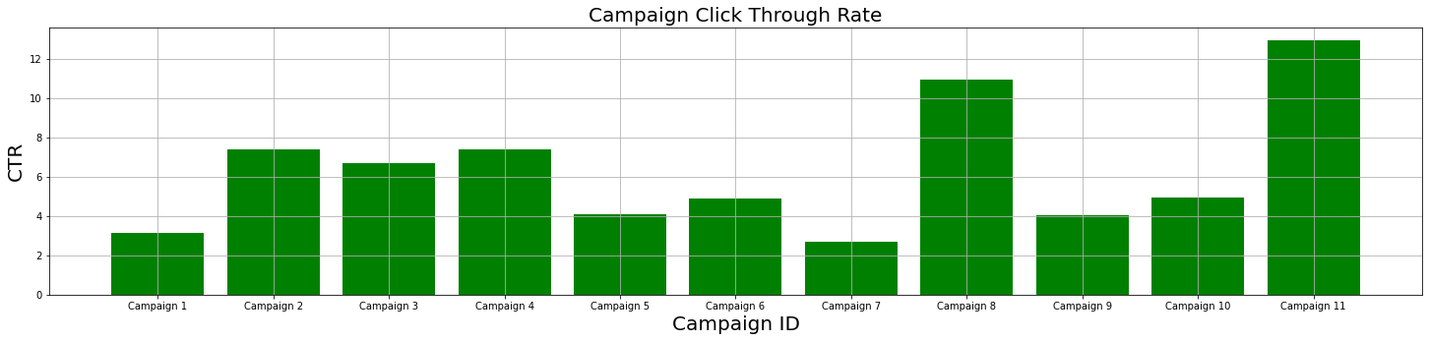

Since CTR or click through rate determine how effective a campaign is at getting people to a website, So in this case Campaign 11 has the higher effectiveness and Campaign 7 has the lower.

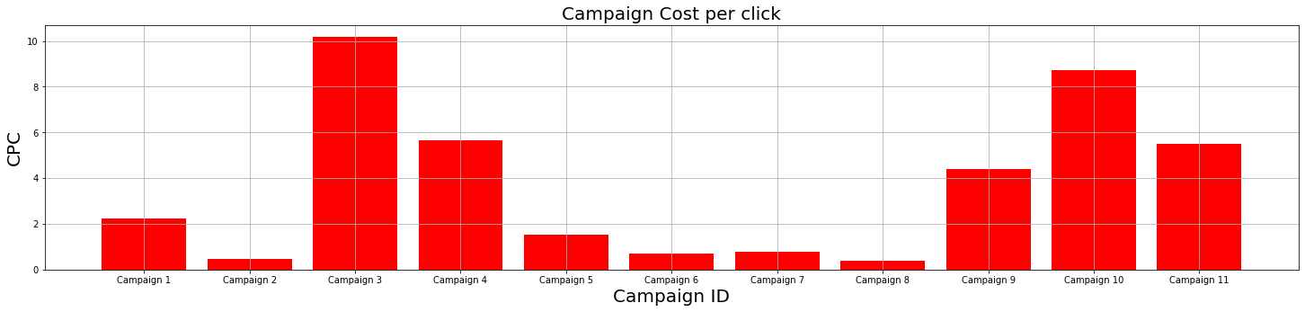

CPC determines how effective a campaign is. Campaign 2 and Campaign 8 have the lower performance.

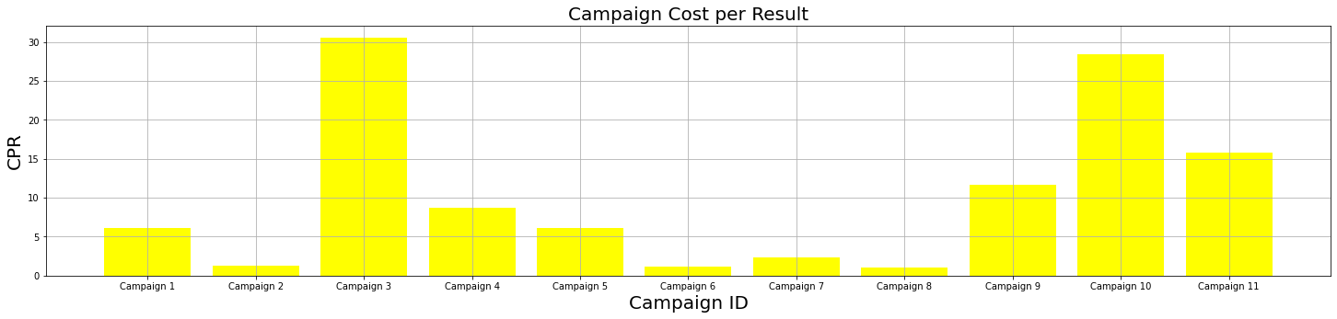

CPR showing the comparison between the campaigns. Campaign 2, 6, 8 have the lower performance. So it advised the low performing Campaign 2, 6, 8 be discontinued.

Here are some other Results:

